第十三章 异常处理

异常处理概述
- Spring MVC 通过 HandlerExceptionResolver 处理程序的异常，包括 Handler 映射、数据绑定以及目标方法执行时发生的异常。
- SpringMVC 提供的 HandlerExceptionResolver 的实现类
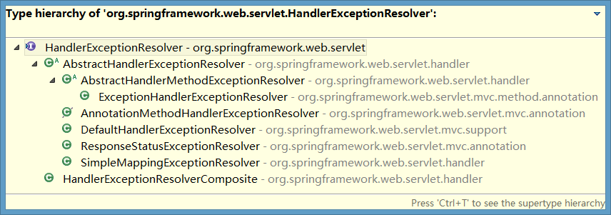

HandlerExceptionResolver
DispatcherServlet 默认装配的 HandlerExceptionResolver ：
ExceptionHandlerExceptionResolver，处理标注了注解@ExceptionHandler的处理异常方法；
ResponseStatusExceptionResolver，处理标注了注解@ResponseStatus的异常；
DefaultHandlerExceptionResolver，判断是否是SpringMvc自带的异常；

@ExceptionHandler的使用，在目标方法的类中创建异常处理方法，标注@ExceptionHandler，表示该方法用于处理该类中的异常，同时可以在该注解中添加要处理的异常类型。如果要接受该方法的异常，则在参数中添加一个Exception参数，同时将该参数添加到ModelAndView中返回，如果要转发到一个自定义的异常处理页面中，直接返回该页面的逻辑视图即可。

@ResponseStatus的使用，用于标注自定义异常类，通过属性reason表示该异常的原因，通过value属性表示该异常的响应状态码。它的处理顺序在@ExceptionHandler异常处理方法中的异常之后。

如果ExceptionHandlerExceptionResolver以及ResponseStatusExceptionResolver都没有对应的异常处理类能够处理当前的异常，那么就会使用DefaultHandlerExceptionResolver默认处理器来处理。

- 没有使用 <mvc:annotation-driven/> 配置：
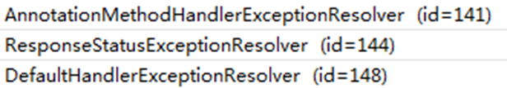
- 使用了 <mvc:annotation-driven/> 配置：
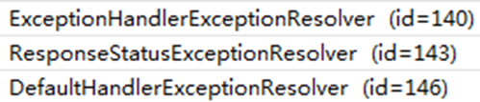

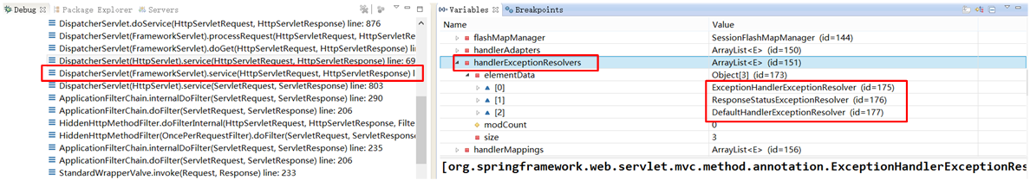

实验代码
- 页面链接
<a href="testExceptionHandlerExceptionResolver?i=1">testExceptionHandlerExceptionResolver</a>
- 控制器方法
package com.atguigu.springmvc.crud.handlers;

import org.springframework.stereotype.Controller;
import org.springframework.web.bind.annotation.RequestMapping;
import org.springframework.web.bind.annotation.RequestParam;

@Controller
public class ExceptionHandler {
@RequestMapping("/testExceptionHandlerExceptionResolver")
public String testExceptionHandlerExceptionResolver(@RequestParam("i") int i){
System.out.println("10/"+i+"="+(10/i));
return "success";
}
}
- 测试，出现异常情况
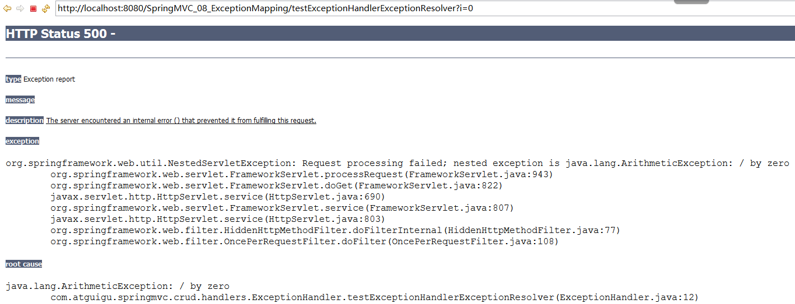
处理异常，跳转到error.jsp
- 在控制器中增加处理异常的方法
@ExceptionHandler(value={java.lang.ArithmeticException.class})
public String handleException(Exception ex){
System.out.println("出现异常啦☹"+ex);
return "error";
}
- 增加error.jsp
<h3>Error Page</h3>

如何将异常对象从控制器携带给页面，做异常信息的获取
- 异常对象不能通过Map集合方式传递给成功页面。（Map不可以）
可以将Exception异常对象添加到ModelAndView中
// @ExceptionHandler(value={java.lang.ArithmeticException.class})
public String handleException(Exception ex,Map<String,Object> map){
System.out.println("出现异常啦:"+ex);
map.put("exception",ex);
return "error";
}
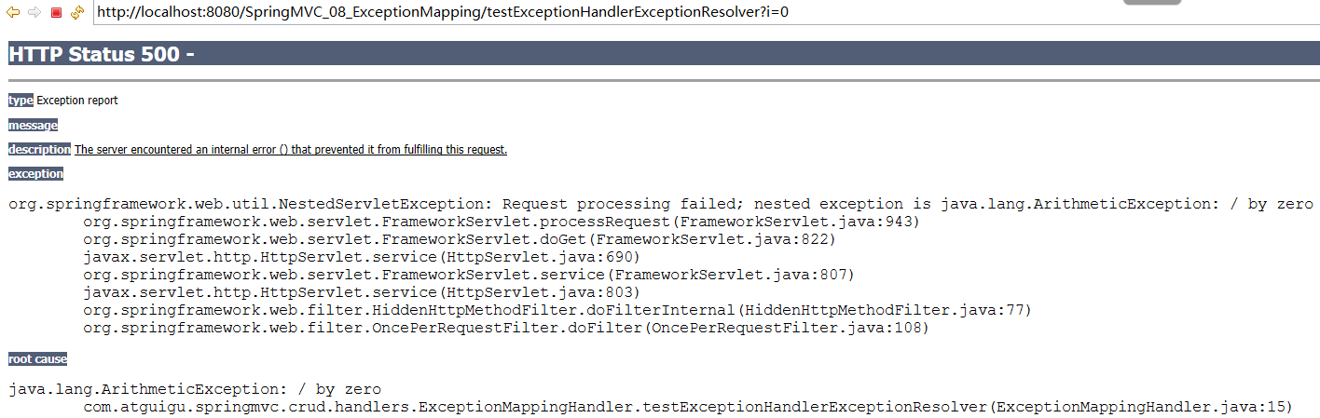
- 可以通过ModelAndView将异常对象传递给成功页面上
@ExceptionHandler(value={java.lang.ArithmeticException.class})
public ModelAndView handleException(Exception ex){
System.out.println("出现异常啦:"+ex);
ModelAndView mv = new ModelAndView("error");
mv.addObject("exception", ex);
return mv;
}

匹配异常类型，执行顺序问题
@ExceptionHandler(value={java.lang.ArithmeticException.class})
public ModelAndView handleException(Exception ex){
System.out.println("出现异常啦:"+ex);
ModelAndView mv = new ModelAndView("error");
mv.addObject("exception", ex);
return mv;
}

@ExceptionHandler(value={java.lang.RuntimeException.class})
public ModelAndView handleException2(Exception ex){
System.out.println("RuntimeException-出现异常啦:"+ex);
ModelAndView mv = new ModelAndView("error");
mv.addObject("exception", ex);
return mv;
}

公共的处理异常的类@ControllerAdvice
如果我们想要将通用的处理异常方法抽取到一个公共的处理异常的类中，需要在类上添加注解@ControllerAdvice。
公共处理类中的异常处理方法的优先级一定比目标方法中的类中的异常处理方法优先级低。
  - 定义公共的处理异常的类
package com.atguigu.springmvc.exceptionAdvice;

import org.springframework.web.bind.annotation.ControllerAdvice;
import org.springframework.web.bind.annotation.ExceptionHandler;
import org.springframework.web.servlet.ModelAndView;

@ControllerAdvice
public class ExceptionAdviceHandler {

/*
@ExceptionHandler(value={java.lang.ArithmeticException.class})
public ModelAndView handleException(Exception ex){

System.out.println("出现异常啦:"+ex);
ModelAndView mv = new ModelAndView("error");
mv.addObject("exception", ex);

return mv;
}*/

@ExceptionHandler(value={java.lang.RuntimeException.class})
public ModelAndView handleException2(Exception ex){

System.out.println("RuntimeException-出现异常啦:"+ex);
ModelAndView mv = new ModelAndView("error");
mv.addObject("exception", ex);

return mv;
}
}

ExceptionHandlerExceptionResolver
- 主要处理 Handler 中用 @ExceptionHandler 注解定义的方法。
- @ExceptionHandler 注解定义的方法优先级问题：例如发生的是NullPointerException，但是声明的异常有 RuntimeException 和 Exception，此候会根据异常的最近继承关系找到继承深度最浅的那个 @ExceptionHandler 注解方法，即标记了 RuntimeException 的方法
- ExceptionHandlerMethodResolver 内部若找不到@ExceptionHandler 注解的话，会找 @ControllerAdvice 中的@ExceptionHandler 注解方法

异常处理_ResponseStatusExceptionResolver
- 在异常及异常父类中找到 @ResponseStatus 注解，然后使用这个注解的属性进行处理。
- 定义一个 @ResponseStatus 注解修饰的异常类
- 若在处理器方法中抛出了上述异常：若ExceptionHandlerExceptionResolver 不解析上述异常。由于触发的异常 UnauthorizedException 带有@ResponseStatus 注解。因此会被ResponseStatusExceptionResolver 解析到。最后响应HttpStatus.UNAUTHORIZED 代码给客户端。HttpStatus.UNAUTHORIZED 代表响应码401，无权限。 关于其他的响应码请参考 HttpStatus 枚举类型源码。

org.springframework.web.servlet.mvc.annotation.ResponseStatusExceptionResolver
Implementation of the HandlerExceptionResolver interface that uses the @ResponseStatus annotation to map exceptions to HTTP status codes.
This exception resolver is enabled by default in the
org.springframework.web.servlet.DispatcherServlet.

实验代码
- 页面链接
<a href="testResponseStatusExceptionResolver?i=10">testResponseStatusExceptionResolver</a>
- 自定义异常类
package com.atguigu.springmvc.exception;

import org.springframework.http.HttpStatus;
import org.springframework.web.bind.annotation.ResponseStatus;

/**
* 自定义异常类
HttpStatus.FORBIDDEN 不允许的，禁用的
*/
@ResponseStatus(value=HttpStatus.FORBIDDEN,reason="用户名称和密码不匹配")
public class UsernameNotMatchPasswordException extends RuntimeException{}
- 控制器方法
@RequestMapping(value="/testResponseStatusExceptionResolver")
public String testResponseStatusExceptionResolver(@RequestParam("i") int i){
if(i==13){
throw new UsernameNotMatchPasswordException();
}
System.out.println("testResponseStatusExceptionResolver...");
return "success";
}
- 出现的错误消息
- 没使用注解时：@ResponseStatus(value=HttpStatus.FORBIDDEN,reason="用户名称和密码不匹配")
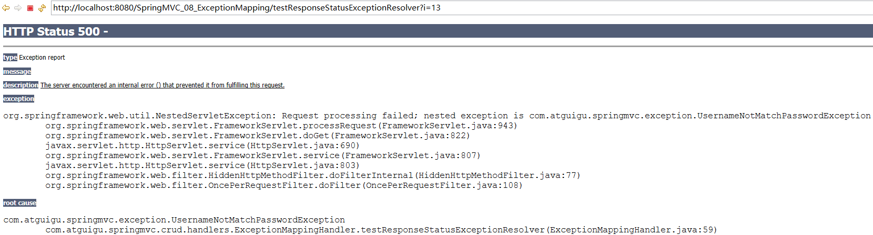
- 使用注解时：@ResponseStatus(value=HttpStatus.FORBIDDEN,reason="用户名称和密码不匹配")
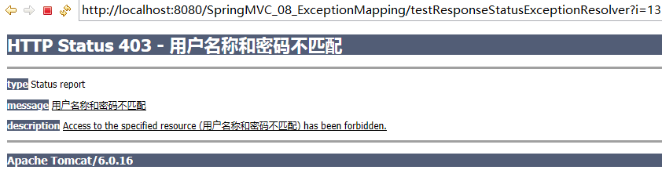
- 测试在方法上使用注解
@ResponseStatus(value=HttpStatus.NOT_FOUND,reason="测试方法上设置响应状态码")
@RequestMapping(value="/testResponseStatusExceptionResolver")
public String testResponseStatusExceptionResolver(@RequestParam("i") int i){
if(i==13){
throw new UsernameNotMatchPasswordException();
}
System.out.println("testResponseStatusExceptionResolver...");
return "success";
}
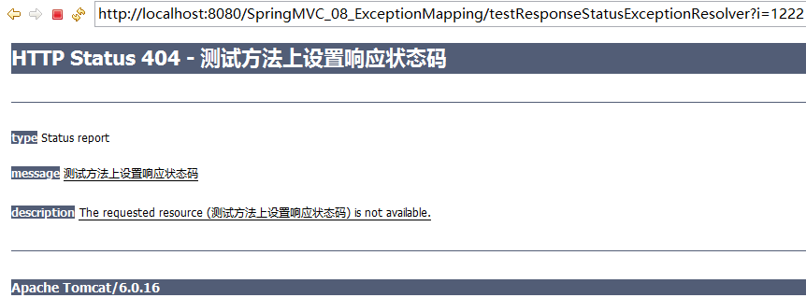
- ResponseStatus
package org.springframework.web.bind.annotation;

import java.lang.annotation.Documented;
import java.lang.annotation.ElementType;
import java.lang.annotation.Retention;
import java.lang.annotation.RetentionPolicy;
import java.lang.annotation.Target;

import org.springframework.http.HttpStatus;

/**
* Marks a method or exception class with the status code and reason that should be returned. The status code is applied
* to the HTTP response when the handler method is invoked, or whenever said exception is thrown.
*
* @author Arjen Poutsma
* @see org.springframework.web.servlet.mvc.annotation.ResponseStatusExceptionResolver
* @since 3.0
*/
@Target({ElementType.TYPE, ElementType.METHOD})
@Retention(RetentionPolicy.RUNTIME)
@Documented
public @interface ResponseStatus {

HttpStatus value();

String reason() default "";

}
- HttpStatus

异常处理_DefaultHandlerExceptionResolver
- 对一些特殊的异常进行处理，比如：
  - NoSuchRequestHandlingMethodException、
  - HttpRequestMethodNotSupportedException、
  - HttpMediaTypeNotSupportedException、
  - HttpMediaTypeNotAcceptableException等。
- javadoc
org.springframework.web.servlet.mvc.support.DefaultHandlerExceptionResolver
Default implementation of the HandlerExceptionResolver interface that resolves standard Spring exceptions and translates them to corresponding HTTP status codes.
This exception resolver is enabled by default in the org.springframework.web.servlet.DispatcherServlet.

实验代码
- 增加页面链接：GET请求
<a href="testDefaultHandlerExceptionResolver">testDefaultHandlerExceptionResolver</a>
增加处理器方法
//@RequestMapping(value="/testDefaultHandlerExceptionResolver")
@RequestMapping(value="/testDefaultHandlerExceptionResolver",method=RequestMethod.POST) //不支持GET请求
public String testDefaultHandlerExceptionResolver(){
System.out.println("testDefaultHandlerExceptionResolver...");
return "success";
}
- 出现异常错误
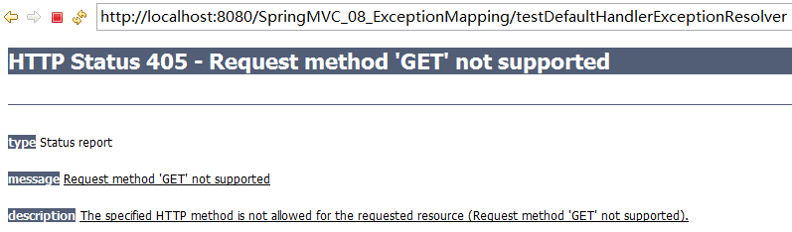
- 出现异常交给DefaultHandlerExceptionResolver处理
@Override
protected ModelAndView doResolveException(
HttpServletRequest request, HttpServletResponse response, Object handler, Exception ex) {

try {
if (ex instanceof NoSuchRequestHandlingMethodException) {
return handleNoSuchRequestHandlingMethod((NoSuchRequestHandlingMethodException) ex, request, response,
handler);
}
else if (ex instanceof HttpRequestMethodNotSupportedException) {
return handleHttpRequestMethodNotSupported((HttpRequestMethodNotSupportedException) ex, request,
response, handler);
}
else if (ex instanceof HttpMediaTypeNotSupportedException) {
return handleHttpMediaTypeNotSupported((HttpMediaTypeNotSupportedException) ex, request, response,
handler);
}
else if (ex instanceof HttpMediaTypeNotAcceptableException) {
return handleHttpMediaTypeNotAcceptable((HttpMediaTypeNotAcceptableException) ex, request, response,
handler);
}
else if (ex instanceof MissingServletRequestParameterException) {
return handleMissingServletRequestParameter((MissingServletRequestParameterException) ex, request,
response, handler);
}
else if (ex instanceof ServletRequestBindingException) {
return handleServletRequestBindingException((ServletRequestBindingException) ex, request, response,
handler);
}
else if (ex instanceof ConversionNotSupportedException) {
return handleConversionNotSupported((ConversionNotSupportedException) ex, request, response, handler);
}
else if (ex instanceof TypeMismatchException) {
return handleTypeMismatch((TypeMismatchException) ex, request, response, handler);
}
else if (ex instanceof HttpMessageNotReadableException) {
return handleHttpMessageNotReadable((HttpMessageNotReadableException) ex, request, response, handler);
}
else if (ex instanceof HttpMessageNotWritableException) {
return handleHttpMessageNotWritable((HttpMessageNotWritableException) ex, request, response, handler);
}
else if (ex instanceof MethodArgumentNotValidException) {
return handleMethodArgumentNotValidException((MethodArgumentNotValidException) ex, request, response, handler);
}
else if (ex instanceof MissingServletRequestPartException) {
return handleMissingServletRequestPartException((MissingServletRequestPartException) ex, request, response, handler);
}
else if (ex instanceof BindException) {
return handleBindException((BindException) ex, request, response, handler);
}
else if (ex instanceof NoHandlerFoundException) {
return handleNoHandlerFoundException((NoHandlerFoundException) ex, request, response, handler);
}
}
catch (Exception handlerException) {
logger.warn("Handling of [" + ex.getClass().getName() + "] resulted in Exception", handlerException);
}
return null;
}

异常处理_SimpleMappingExceptionResolver
- 如果希望对所有异常进行统一处理，可以使用 SimpleMappingExceptionResolver，它将异常类名映射为视图名，即发生异常时使用对应的视图报告异常
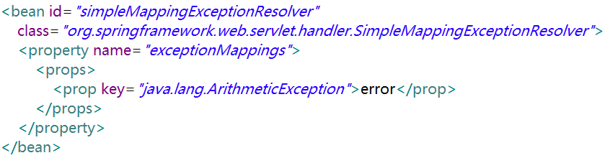

实验代码
- 增加页面链接
<a href="testSimpleMappingExceptionResolver?i=1">testSimpleMappingExceptionResolver</a>
- 增加控制器方法
@RequestMapping("/testSimpleMappingExceptionResolver")
public String testSimpleMappingExceptionResolver(@RequestParam("i") int i){
System.out.println("testSimpleMappingExceptionResolver...");
String[] s = new String[10];
System.out.println(s[i]);
return "success";
}
- 出现异常情况：参数i的值大于10
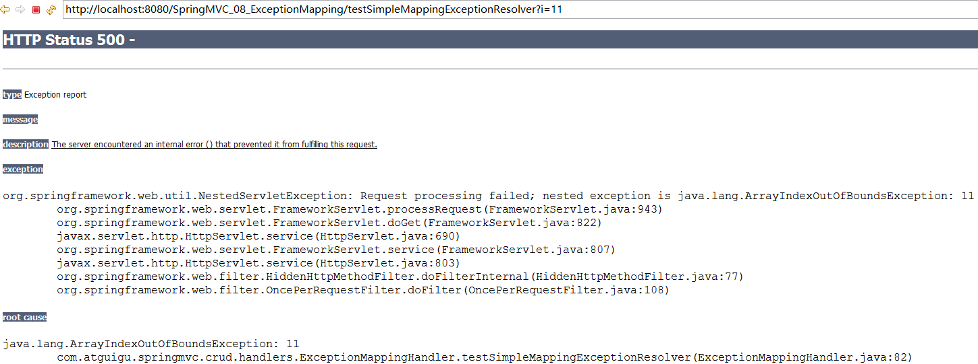
- 配置异常解析器:自动将异常对象信息，存放到request范围内
<!-- 配置SimpleMappingExceptionResolver异常解析器 -->
<bean id="simpleMappingExceptionResolver"
class="org.springframework.web.servlet.handler.SimpleMappingExceptionResolver">
<!-- exceptionAttribute默认值(通过ModelAndView传递给页面)：
exception -> ${requestScope.exception}
public static final String DEFAULT_EXCEPTION_ATTRIBUTE = "exception";
-->
<property name="exceptionAttribute" value="exception"></property>
<property name="exceptionMappings">
<props>
<prop key="java.lang.ArrayIndexOutOfBoundsException">error</prop>
</props>
</property>
</bean>

error.jsp
<%@ page language="java" contentType="text/html; charset=UTF-8"
pageEncoding="UTF-8"%>
<!DOCTYPE html PUBLIC "-//W3C//DTD HTML 4.01 Transitional//EN"
"http://www.w3.org/TR/html4/loose.dtd">
<html>
<head>
<meta http-equiv="Content-Type" content="text/html; charset=UTF-8">
<title>Insert title here</title>
</head>
<body>
<h3>Error Page</h3>
${exception }
${requestScope.exception }
</body>
</html>
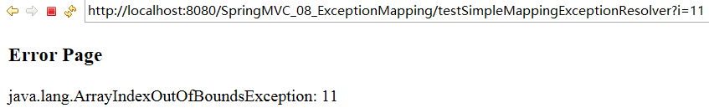
- 源码分析
SimpleMappingExceptionResolver L187 L339
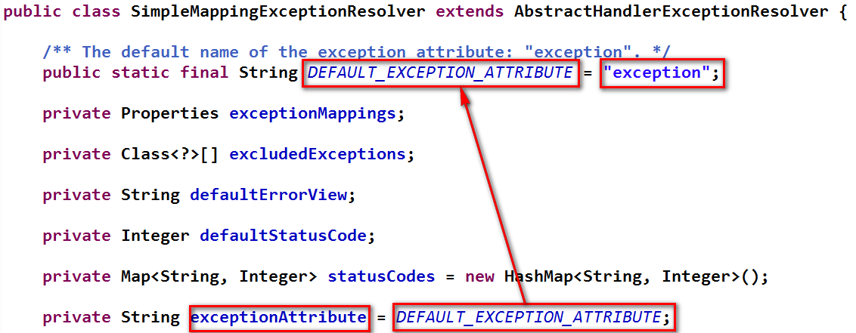
@Override
protected ModelAndView doResolveException(HttpServletRequest request,
HttpServletResponse response,Object handler, Exception ex) {

// Expose ModelAndView for chosen error view.
String viewName = determineViewName(ex, request);
if (viewName != null) {
// Apply HTTP status code for error views, if specified.
// Only apply it if we're processing a top-level request.
Integer statusCode = determineStatusCode(request, viewName);
if (statusCode != null) {
applyStatusCodeIfPossible(request, response, statusCode);
}
return getModelAndView(viewName, ex, request);
}else {
return null;
}
}
/**
* Return a ModelAndView for the given view name and exception.
* <p>The default implementation adds the specified exception attribute.
* Can be overridden in subclasses.
* @param viewName the name of the error view
* @param ex the exception that got thrown during handler execution
* @return the ModelAndView instance
* @see #setExceptionAttribute
*/
protected ModelAndView getModelAndView(String viewName, Exception ex) {
ModelAndView mv = new ModelAndView(viewName);
if (this.exceptionAttribute != null) {
if (logger.isDebugEnabled()) {
logger.debug("Exposing Exception as model attribute '" + this.exceptionAttribute + "'");
}
mv.addObject(this.exceptionAttribute, ex);
}
return mv;
}

